Onda 5 confirmatórias e logits partido mais citado

Argentina

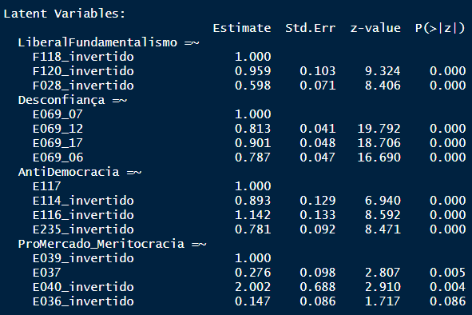

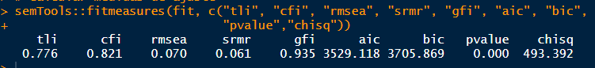

32% da amostra= Justicialista

|  |  |  |  |  |
| --- | --- | --- | --- | --- |
|  | Justicialista | Justicialista | Justicialista | Justicialista |
| Predictors | Odds Ratios | Odds Ratios | Odds Ratios | Odds Ratios |
| (Intercept) | 3.50 ** (1.43) | 0.48 *** (0.03) | 0.27 *** (0.07) | 2.11  (1.02) |
| X049 | 0.88 *** (0.03) |  |  | 0.91 ** (0.03) |
| Gender | 0.58 *** (0.09) |  |  | 0.59 ** (0.10) |
| idade_faixa | 1.17  (0.13) |  |  | 1.12  (0.12) |
| escolaridade_niveis | 0.71 ** (0.08) |  |  | 0.61 *** (0.08) |
| status_emploSelf Employed | 0.80  (0.19) |  |  | 0.83  (0.20) |
| status_emploHousewife | 1.01  (0.24) |  |  | 1.02  (0.25) |
| status_emploRetired | 1.13  (0.29) |  |  | 1.15  (0.30) |
| status_emploStudent | 0.99  (0.33) |  |  | 1.08  (0.37) |
| status_emploOthers | 0.77  (0.16) |  |  | 0.87  (0.19) |
| religionDo not belong to a denomination | 0.73  (0.15) |  |  | 0.78  (0.17) |
| religionOthers | 1.23  (0.28) |  |  | 1.24  (0.29) |
| fundamentalism |  | 1.90  (0.87) | 1.82  (0.88) | 0.85  (0.45) |
| antidemocr |  | 0.39  (0.33) | 0.33  (0.29) | 0.24  (0.22) |
| desconfia |  | 0.17 *** (0.07) | 0.22 *** (0.10) | 0.26 ** (0.12) |
| promercado |  | 1.12  (0.66) | 1.03  (0.62) | 1.19  (0.74) |
| autoloc_dir_esqCenter |  |  | 1.86 * (0.47) | 1.86 * (0.49) |
| autoloc_dir_esqRight |  |  | 2.09 ** (0.55) | 1.98 * (0.54) |
| autoloc_dir_esqDon't Know |  |  | 1.26  (0.34) | 1.18  (0.33) |
| interesse |  |  | 1.43  (0.36) | 1.83 * (0.50) |
| Observations | 1002 | 1002 | 992 | 992 |
| R2 Tjur | 0.066 | 0.027 | 0.044 | 0.100 |
| * p<0.05   ** p<0.01   *** p<0.001 | | | | |

#

Brasil – partido mais citado: PT 38%

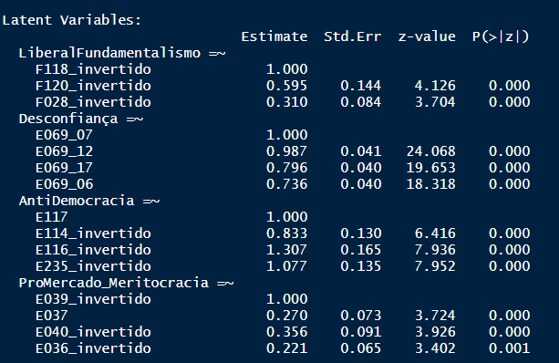



|  |  |  |  |  |
| --- | --- | --- | --- | --- |
| PT_ | PT_ | PT_ | PT_ |  |
| Predictors | Odds Ratios | Odds Ratios | Odds Ratios | Odds Ratios |
| (Intercept) | 0.46  (0.29) | 0.62 *** (0.03) | 0.78  (0.11) | 0.70  (0.47) |
| X049 | 1.17 *** (0.05) |  |  | 1.15 *** (0.05) |
| Gender | 0.93  (0.11) |  |  | 0.99  (0.13) |
| region76003 | 1.45  (0.99) |  |  | 1.20  (0.87) |
| region76005 | 2.00  (1.32) |  |  | 3.06  (2.13) |
| region76006 | 1.55  (0.83) |  |  | 1.74  (0.99) |
| region76007 | 3.28 * (1.88) |  |  | 4.15 * (2.54) |
| region76008 | 1.60  (0.98) |  |  | 2.33  (1.52) |
| region76009 | 0.46  (0.30) |  |  | 0.50  (0.35) |
| region76010 | 2.86  (1.62) |  |  | 2.66  (1.62) |
| region76011 | 0.83  (0.53) |  |  | 0.90  (0.61) |
| region76012 | 0.46  (0.43) |  |  | 0.49  (0.48) |
| region76013 | 1.74  (0.86) |  |  | 1.84  (0.98) |
| region76014 | 0.98  (0.59) |  |  | 1.04  (0.66) |
| region76015 | 1.43  (0.83) |  |  | 1.64  (1.03) |
| region76016 | 1.07  (0.57) |  |  | 1.23  (0.70) |
| region76017 | 2.06  (1.19) |  |  | 2.40  (1.48) |
| region76019 | 1.09  (0.54) |  |  | 1.22  (0.65) |
| region76020 | 0.54  (0.50) |  |  | 0.56  (0.54) |
| region76021 | 1.02  (0.55) |  |  | 1.18  (0.69) |
| region76024 | 0.99  (0.64) |  |  | 1.15  (0.79) |
| region76025 | 1.39  (0.67) |  |  | 1.59  (0.82) |
| raca_brancTRUE | 0.71 ** (0.09) |  |  | 0.67 ** (0.08) |
| renda_subj_numeric | 1.11  (0.11) |  |  | 1.18  (0.12) |
| idade_faixa | 0.89  (0.08) |  |  | 0.87  (0.08) |
| escolaridade_niveis | 0.67 *** (0.06) |  |  | 0.56 *** (0.06) |
| status_emploSelf Employed | 0.87  (0.15) |  |  | 0.89  (0.16) |
| status_emploHousewife | 1.15  (0.25) |  |  | 1.14  (0.25) |
| status_emploRetired | 1.02  (0.22) |  |  | 1.05  (0.23) |
| status_emploStudent | 1.15  (0.34) |  |  | 1.18  (0.36) |
| status_emploOthers | 1.30  (0.21) |  |  | 1.29  (0.22) |
| religionDo not belong to a denomination | 0.99  (0.18) |  |  | 0.90  (0.17) |
| religionOthers | 0.72 * (0.10) |  |  | 0.77  (0.11) |
| fundamentalism |  | 0.95  (0.39) | 1.15  (0.48) | 1.14  (0.54) |
| antidemocr |  | 0.20  (0.18) | 0.27  (0.25) | 0.06 ** (0.06) |
| desconfia |  | 0.24 *** (0.07) | 0.31 *** (0.09) | 0.40 ** (0.12) |
| promercado |  | 0.46 * (0.15) | 0.47 * (0.16) | 0.63  (0.23) |
| autoloc_dir_esqCenter |  |  | 0.54 *** (0.08) | 0.47 *** (0.08) |
| autoloc_dir_esqRight |  |  | 0.60 *** (0.09) | 0.51 *** (0.08) |
| autoloc_dir_esqDon't Know |  |  | 0.46 *** (0.11) | 0.34 *** (0.09) |
| interesse |  |  | 1.61 ** (0.29) | 1.92 *** (0.37) |
| Observations | 1478 | 1500 | 1474 | 1454 |
| R2 Tjur | 0.072 | 0.022 | 0.044 | 0.120 |
| * p<0.05   ** p<0.01   *** p<0.001 | | | | |

#Chile



Partido Socialista = 14,5% o mais citado

removi promercado do resto da análise:

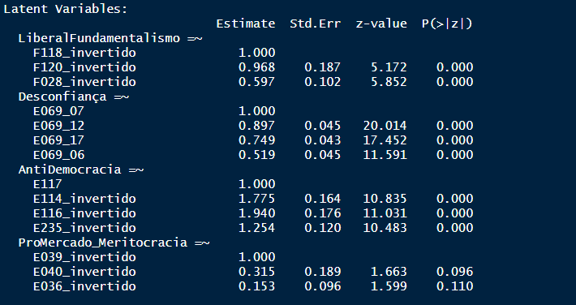

regressão logit

|  |  |  |  |  |
| --- | --- | --- | --- | --- |
|  | PartidoSocialista | PartidoSocialista | PartidoSocialista | PartidoSocialista |
| Predictors | Odds Ratios | Odds Ratios | Odds Ratios | Odds Ratios |
| (Intercept) | 0.14 * (0.12) | 0.16 *** (0.02) | 0.41 *** (0.08) | 0.50  (0.46) |
| Gender | 0.98  (0.21) |  |  | 1.11  (0.25) |
| cidade_maior_binTRUE | 1.01  (0.26) |  |  | 0.97  (0.26) |
| idade_faixa | 0.99  (0.15) |  |  | 0.95  (0.16) |
| escolaridade_niveis | 1.12  (0.19) |  |  | 0.93  (0.18) |
| status_emploSelf Employed | 0.62  (0.23) |  |  | 0.68  (0.27) |
| status_emploHousewife | 0.74  (0.21) |  |  | 0.79  (0.25) |
| status_emploRetired | 1.37  (0.44) |  |  | 1.61  (0.55) |
| status_emploStudent | 0.42  (0.19) |  |  | 0.38 * (0.18) |
| status_emploOthers | 0.62  (0.19) |  |  | 0.63  (0.21) |
| rend_subjDK | 0.65  (0.45) |  |  | 0.54  (0.40) |
| rend_subjLow | 1.30  (0.64) |  |  | 1.05  (0.55) |
| rend_subjMedium | 1.33  (0.62) |  |  | 0.92  (0.46) |
| religionCatholic | 0.95  (0.23) |  |  | 1.12  (0.30) |
| religionOthers | 0.85  (0.26) |  |  | 1.11  (0.38) |
| *fundamentalism* |  | *0.61  (0.39)* | *0.98  (0.69)* | *0.62  (0.48)* |
| *antidemocr* |  | *0.06 ** (0.06)* | *0.46  (0.55)* | *0.39  (0.47)* |
| *desconfia* |  | *0.47  (0.21)* | *1.08  (0.52)* | *1.20  (0.60)* |
| autoloc_dir_esqCenter |  |  | 0.38 *** (0.09) | 0.36 *** (0.09) |
| autoloc_dir_esqRight |  |  | 0.18 *** (0.05) | 0.17 *** (0.05) |
| autoloc_dir_esqDon't Know |  |  | 0.11 *** (0.04) | 0.10 *** (0.03) |
| interesse |  |  | 1.80  (0.56) | 2.04 * (0.67) |
| Observations | 998 | 1000 | 992 | 991 |
| R2 Tjur | 0.014 | 0.011 | 0.110 | 0.131 |
| * p<0.05   ** p<0.01   *** p<0.001 | | | | |

#Guatemala

partido + citado = GANA 44,8%

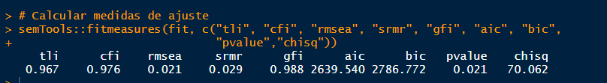

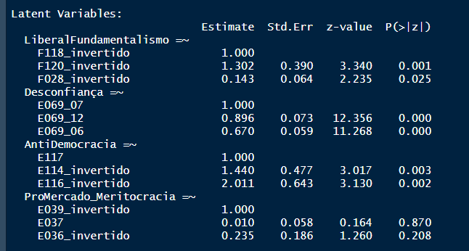

OBS: decidi abdicar de promercado

|  |  |  |  |  |
| --- | --- | --- | --- | --- |
|  | GANA_ | GANA_ | GANA_ | GANA_ |
| Predictors | Odds Ratios | Odds Ratios | Odds Ratios | Odds Ratios |
| (Intercept) | 0.41 * (0.18) | 0.81 *** (0.05) | 0.61 ** (0.11) | 0.34 * (0.17) |
| X049 | 0.99  (0.02) |  |  | 0.98  (0.02) |
| Gender | 0.87  (0.14) |  |  | 0.87  (0.14) |
| color_race_ladino_guatemalaTRUE | 0.96  (0.14) |  |  | 0.98  (0.15) |
| rend_subj_level_recodedDK | 0.88  (0.31) |  |  | 0.80  (0.29) |
| rend_subj_level_recodedLow | 0.77  (0.16) |  |  | 0.73  (0.16) |
| idade_faixa | 1.19  (0.12) |  |  | 1.20  (0.13) |
| escolaridade_niveis | 1.64 *** (0.18) |  |  | 1.57 *** (0.18) |
| status_emploHousewife | 1.70 ** (0.34) |  |  | 1.75 ** (0.35) |
| status_emploStudent | 0.75  (0.22) |  |  | 0.76  (0.22) |
| status_emploOthers | 0.97  (0.16) |  |  | 0.93  (0.16) |
| religionDo not belong to a denomination | 0.71  (0.17) |  |  | 0.71  (0.17) |
| religionOthers | 0.82  (0.12) |  |  | 0.83  (0.12) |
| fundamentalism |  | 0.69  (0.34) | 0.83  (0.42) | 0.92  (0.48) |
| antidemocr |  | 0.00 ** (0.00) | 0.00 ** (0.00) | 0.01  (0.03) |
| desconfia |  | 0.24 *** (0.10) | 0.28 ** (0.11) | 0.25 ** (0.11) |
| autoloc_dir_esqCenter |  |  | 1.00  (0.22) | 1.00  (0.23) |
| autoloc_dir_esqRight |  |  | 1.47 * (0.27) | 1.58 * (0.30) |
| autoloc_dir_esqDon't Know |  |  | 0.86  (0.19) | 0.93  (0.21) |
| interesse |  |  | 1.54  (0.35) | 1.36  (0.32) |
| Observations | 1000 | 1000 | 995 | 995 |
| R2 Tjur | 0.036 | 0.016 | 0.034 | 0.066 |
| * p<0.05   ** p<0.01   *** p<0.001 | | | | |

#

Mexico – PAN mais citado 25,4%

Latent Variables:

Estimate Std.Err z-value P(>|z|)

LiberalFundamentalismo =~

F118_invertido 1.000

F120_invertido 0.541 0.120 4.514 0.000

F028_invertido 0.209 0.051 4.079 0.000

Desconfiança =~

E069_07 1.000

E069_12 1.001 0.034 29.250 0.000

E069_17 0.784 0.034 23.394 0.000

E069_06 0.735 0.034 21.522 0.000

AntiDemocracia =~

E117 1.000

E114_invertido -0.077 0.074 -1.049 0.294

E116_invertido 0.296 0.080 3.698 0.000

E235_invertido 1.027 0.155 6.634 0.000

ProMercado_Meritocracia =~

E039_invertido 1.000

E040_invertido 0.506 0.098 5.177 0.000

E036_invertido 0.187 0.047 3.967 0.000

optei por descontinuar com o antidemocracia

> semTools::fitmeasures(fit, c("tli", "cfi", "rmsea", "srmr", "gfi", "aic", "bic",

+ "pvalue","chisq"))

tli cfi rmsea srmr gfi aic bic pvalue chisq

0.800 0.844 0.069 0.061 0.947 6177.198 6359.181 0.000 599.425

refiz sem antidemocracia

'  
Latent Variables:

Estimate Std.Err z-value P(>|z|)

LiberalFundamentalismo =~

F118_invertido 1.000

F120_invertido 0.690 0.149 4.635 0.000

F028_invertido 0.256 0.056 4.566 0.000

Desconfiança =~

E069_07 1.000

E069_12 1.002 0.034 29.197 0.000

E069_17 0.782 0.034 23.315 0.000

E069_06 0.735 0.034 21.519 0.000

ProMercado_Meritocracia =~

E039_invertido 1.000

E040_invertido 0.691 0.188 3.686 0.000

E036_invertido 0.244 0.069 3.536 0.000

> semTools::fitmeasures(fit, c("tli", "cfi", "rmsea", "srmr", "gfi", "aic", "bic",

+ "pvalue","chisq"))#

tli cfi rmsea srmr gfi aic bic pvalue chisq

0.849 0.892 0.080 0.055 0.957 6065.667 6188.773 0.000 348.647

|  |  |  |  |  |
| --- | --- | --- | --- | --- |
|  | PAN_ | PAN_ | PAN_ | PAN_ |
| Predictors | Odds Ratios | Odds Ratios | Odds Ratios | Odds Ratios |
| (Intercept) | 0.30 * (0.16) | 0.34 *** (0.02) | 0.17 *** (0.03) | 0.17 ** (0.09) |
| Gender | 1.11  (0.18) |  |  | 1.15  (0.19) |
| X049 | 0.97  (0.03) |  |  | 0.96  (0.03) |
| region484002 | 0.93  (0.76) |  |  | 1.19  (0.98) |
| region484003 | 1.22  (0.54) |  |  | 1.17  (0.54) |
| region484004 | 0.00  (0.00) |  |  | 0.00  (0.00) |
| region484005 | 1.97  (1.47) |  |  | 1.97  (1.48) |
| region484006 | 1.35  (0.62) |  |  | 1.65  (0.78) |
| region484008 | 0.54  (0.27) |  |  | 0.54  (0.27) |
| region484009 | 1.60  (0.59) |  |  | 1.40  (0.54) |
| region484010 | 1.18  (0.66) |  |  | 1.46  (0.84) |
| region484011 | 5.14 *** (1.68) |  |  | 5.34 *** (1.81) |
| region484012 | 0.20 * (0.15) |  |  | 0.19 * (0.15) |
| region484013 | 2.16  (0.95) |  |  | 2.15  (0.96) |
| region484014 | 2.55 ** (0.74) |  |  | 2.59 ** (0.77) |
| region484015 | 1.13  (0.31) |  |  | 1.17  (0.33) |
| region484016 | 1.22  (0.43) |  |  | 1.26  (0.46) |
| region484017 | 1.01  (0.61) |  |  | 1.16  (0.70) |
| region484018 | 1.18  (0.84) |  |  | 1.08  (0.78) |
| region484019 | 1.84  (0.67) |  |  | 1.83  (0.68) |
| region484020 | 1.11  (0.43) |  |  | 1.12  (0.45) |
| region484021 | 3.05 *** (1.02) |  |  | 3.15 *** (1.08) |
| region484022 | 2.41  (1.14) |  |  | 2.35  (1.14) |
| region484023 | 0.43  (0.46) |  |  | 0.43  (0.46) |
| region484024 | 0.56  (0.30) |  |  | 0.58  (0.31) |
| region484025 | 1.12  (0.47) |  |  | 1.04  (0.44) |
| region484026 | 1.73  (0.87) |  |  | 1.81  (0.94) |
| region484027 | 0.48  (0.37) |  |  | 0.52  (0.41) |
| region484028 | 1.59  (0.60) |  |  | 1.50  (0.57) |
| region484029 | 0.96  (0.80) |  |  | 0.95  (0.80) |
| region484030 | 2.42 ** (0.77) |  |  | 2.40 ** (0.78) |
| region484031 | 1.87  (0.81) |  |  | 1.64  (0.73) |
| region484032 | 0.41  (0.32) |  |  | 0.37  (0.29) |
| idade_faixa | 1.07  (0.10) |  |  | 1.07  (0.10) |
| escolaridade_niveis | 1.05  (0.11) |  |  | 1.03  (0.11) |
| status_emploSelf Employed | 1.07  (0.20) |  |  | 1.09  (0.21) |
| status_emploHousewife | 0.57 ** (0.12) |  |  | 0.58 * (0.13) |
| status_emploStudent | 1.04  (0.31) |  |  | 0.95  (0.29) |
| status_emploOthers | 0.96  (0.18) |  |  | 1.01  (0.19) |
| rend_subjDK | 0.61  (0.16) |  |  | 0.64  (0.17) |
| rend_subjLow | 0.40 *** (0.08) |  |  | 0.40 *** (0.08) |
| rend_subjMedium | 0.54 *** (0.09) |  |  | 0.54 *** (0.09) |
| religionCatholic | 1.42  (0.26) |  |  | 1.34  (0.25) |
| religionOthers | 0.95  (0.25) |  |  | 0.91  (0.25) |
| fundamentalism |  | 0.81  (0.23) | 0.85  (0.24) | *0.94  (0.30)* |
| promercado |  | 1.55  (0.46) | 1.71  (0.51) | *1.55  (0.51)* |
| desconfia |  | 0.78  (0.21) | 1.02  (0.29) | *1.17  (0.36)* |
| autoloc_dir_esqCenter |  |  | 1.89 ** (0.39) | 1.67 * (0.37) |
| autoloc_dir_esqRight |  |  | 2.28 *** (0.40) | 2.32 *** (0.43) |
| autoloc_dir_esqDon't Know |  |  | 1.40  (0.31) | 1.24  (0.30) |
| interesse |  |  | 1.46  (0.28) | 1.17  (0.25) |
| Observations | 1557 | 1560 | 1546 | 1544 |
| R2 Tjur | 0.100 | 0.002 | 0.022 | 0.117 |
| * p<0.05   ** p<0.01   *** p<0.001 | | | | |

#

Peru – APRA 16,73%

…..

Por ausencia de questões F118 e F120 o liberal/fundamentalismo não foi rodado

Latent Variables:

Estimate Std.Err z-value P(>|z|)

Desconfiança =~

E069_07 1.000

E069_12 0.881 0.037 23.760 0.000

E069_17 0.966 0.042 22.978 0.000

E069_06 0.992 0.046 21.710 0.000

AntiDemocracia =~

E117 1.000

E114_invertido 1.035 0.190 5.434 0.000

E116_invertido 3.255 0.766 4.247 0.000

ProMercado_Meritocracia =~

E039_invertido 1.000

E040_invertido 0.460 0.167 2.757 0.006

E036_invertido 0.191 0.082 2.347 0.019

> semTools::fitmeasures(fit, c("tli", "cfi", "rmsea", "srmr", "gfi", "aic", "bic",

+ "pvalue","chisq"))#refazer sem antidemoc

tli cfi rmsea srmr gfi aic bic pvalue chisq

0.838 0.885 0.073 0.043 0.961 2158.626 2280.830 0.000 288.762

|  |  |  |  |  |
| --- | --- | --- | --- | --- |
|  | APRA | APRA | APRA | APRA |
| Predictors | Odds Ratios | Odds Ratios | Odds Ratios | Odds Ratios |
| (Intercept) | 0.48  (0.18) | 0.20 *** (0.01) | 0.22 *** (0.06) | 0.66  (0.33) |
| Gender | 0.54 *** (0.09) |  |  | 0.58 ** (0.10) |
| raca_brancTRUE | 2.03 ** (0.54) |  |  | 2.04 ** (0.55) |
| idade_faixa | 0.99  (0.10) |  |  | 0.97  (0.11) |
| status_emploSelf Employed | 0.85  (0.18) |  |  | 0.82  (0.18) |
| status_emploHousewife | 1.26  (0.35) |  |  | 1.20  (0.34) |
| status_emploStudent | 1.26  (0.35) |  |  | 1.23  (0.34) |
| status_emploOthers | 0.76  (0.22) |  |  | 0.78  (0.23) |
| rend_subjDK | 0.86  (0.24) |  |  | 0.98  (0.28) |
| rend_subjMedium | 0.95  (0.17) |  |  | 1.01  (0.19) |
| rend_subjHigh | 0.59  (0.45) |  |  | 0.62  (0.47) |
| religionCatholic | 1.11  (0.25) |  |  | 1.02  (0.23) |
| religionOthers | 0.78  (0.22) |  |  | 0.72  (0.20) |
| antidemocr |  | 0.55  (0.76) | 0.47  (0.65) | 0.47  (0.67) |
| desconfia |  | 0.20 *** (0.09) | 0.26 ** (0.12) | 0.30 * (0.14) |
| promercado |  | 0.98  (0.48) | 0.91  (0.45) | 0.91  (0.46) |
| autoloc_dir_esqCenter |  |  | 0.88  (0.20) | 0.86  (0.20) |
| autoloc_dir_esqRight |  |  | 1.26  (0.25) | 1.23  (0.25) |
| autoloc_dir_esqDon't Know |  |  | 0.72  (0.17) | 0.73  (0.18) |
| interesse |  |  | 1.60  (0.71) | 1.64  (0.74) |
| escolaridade_niveis |  |  | 0.91  (0.10) | 0.83  (0.11) |
| Observations | 1500 | 1500 | 1500 | 1500 |
| R2 Tjur | 0.020 | 0.010 | 0.018 | 0.036 |
| * p<0.05   ** p<0.01   *** p<0.001 | | | | |

#

Uruguai Onda Cinco

Frente Amplio (38,9%)

Latent Variables:

Estimate Std.Err z-value P(>|z|)

LiberalFundamentalismo =~

F118_invertido 1.000

F120_invertido 1.072 0.222 4.837 0.000

F028_invertido 0.331 0.076 4.326 0.000

Desconfiança =~

E069_07 1.000

E069_12 0.896 0.053 16.999 0.000

E069_17 0.688 0.049 14.137 0.000

E069_06 0.531 0.048 11.133 0.000

AntiDemocracia =~

E117 1.000

E114_invertido 0.226 0.055 4.091 0.000

E116_invertido 0.589 0.058 10.139 0.000

E235_invertido 0.591 0.054 11.011 0.000

ProMercado_Meritocracia =~

E039_invertido 1.000

E040_invertido 1.941 0.525 3.697 0.000

E036_invertido 0.799 0.167 4.792 0.000

|  |  |  |  |  |
| --- | --- | --- | --- | --- |
|  | FrenteAmplio_ | FrenteAmplio_ | FrenteAmplio_ | FrenteAmplio_ |
| Predictors | Odds Ratios | Odds Ratios | Odds Ratios | Odds Ratios |
| (Intercept) | 1.14  (0.93) | 0.60 *** (0.04) | 3.48 *** (1.05) | 14.52 * (15.26) |
| Gender | 0.80  (0.12) |  |  | 0.85  (0.16) |
| region858002 | 0.56  (0.36) |  |  | 0.44  (0.32) |
| region858003 | 0.72  (0.56) |  |  | 0.34  (0.31) |
| region858004 | 1.01  (0.70) |  |  | 0.25  (0.20) |
| region858005 | 0.32  (0.31) |  |  | 0.23  (0.25) |
| region858006 | 0.59  (0.54) |  |  | 0.49  (0.54) |
| region858007 | 0.86  (0.58) |  |  | 0.44  (0.34) |
| region858008 | 1.01  (0.81) |  |  | 0.56  (0.50) |
| region858009 | 1.45  (0.97) |  |  | 0.34  (0.27) |
| region858010 | 1.11  (0.66) |  |  | 0.54  (0.36) |
| region858011 | 0.89  (0.58) |  |  | 0.45  (0.33) |
| region858012 | 1.94  (1.66) |  |  | 1.00  (1.01) |
| region858013 | 0.45  (0.36) |  |  | 0.25  (0.24) |
| region858014 | 0.15  (0.18) |  |  | 0.08  (0.11) |
| region858016 | 0.96  (0.73) |  |  | 0.43  (0.41) |
| region858017 | 0.63  (0.54) |  |  | 0.36  (0.36) |
| region858018 | 1.78  (1.42) |  |  | 3.04  (2.76) |
| region858019 | 1.08  (0.73) |  |  | 0.60  (0.46) |
| region858020 | 0.64  (0.54) |  |  | 0.34  (0.34) |
| X049 | 1.15 *** (0.04) |  |  | 1.10 * (0.05) |
| raca_brancTRUE | 1.85 * (0.53) |  |  | 1.40  (0.50) |
| idade_faixa | 0.71 *** (0.07) |  |  | 0.76 * (0.10) |
| status_emploSelf Employed | 0.79  (0.19) |  |  | 0.79  (0.23) |
| status_emploHousewife | 0.96  (0.23) |  |  | 1.14  (0.34) |
| status_emploStudent | 0.82  (0.32) |  |  | 1.00  (0.48) |
| status_emploOthers | 0.77  (0.13) |  |  | 0.88  (0.19) |
| rend_subjDK | 0.46  (0.27) |  |  | 0.72  (0.54) |
| rend_subjLow | 0.58  (0.23) |  |  | 0.85  (0.44) |
| rend_subjMedium | 0.49  (0.19) |  |  | 0.77  (0.37) |
| religionCatholic | 0.89  (0.14) |  |  | 0.84  (0.16) |
| religionOthers | 0.79  (0.18) |  |  | 0.85  (0.25) |
| fundamentalism |  | 0.12 *** (0.05) | 0.37  (0.21) | 0.40  (0.26) |
| antidemocr |  | 0.23 ** (0.11) | 0.54  (0.30) | 0.49  (0.32) |
| desconfia |  | 0.12 *** (0.04) | 0.18 *** (0.08) | 0.14 *** (0.06) |
| promercado |  | 0.32  (0.34) | 0.55  (0.72) | 0.72  (0.99) |
| autoloc_dir_esqCenter |  |  | 0.16 *** (0.03) | 0.15 *** (0.03) |
| autoloc_dir_esqRight |  |  | 0.05 *** (0.01) | 0.05 *** (0.01) |
| autoloc_dir_esqDon't Know |  |  | 0.09 *** (0.03) | 0.08 *** (0.03) |
| interesse |  |  | 3.02 *** (0.77) | 3.08 *** (0.84) |
| escolaridade_niveis |  |  | 0.77 * (0.10) | 0.62 ** (0.10) |
| Observations | 1000 | 1000 | 982 | 982 |
| R2 Tjur | 0.089 | 0.107 | 0.363 | 0.393 |
| * p<0.05   ** p<0.01   *** p<0.001 | | | | |

#

final

Tabela – onda 5 – resultados da análise fatorial confirmatória

ver tabelas resultados analise fatorial confirmatoria.xlsx